**ASCENDING ORDER**

**AIM:** To compute ascending order of an array using 8085 processor.

**ALGORITHM:**

1. Initialize HL pair as memory pointer.
2. Get the count at memory and load it into C register
3. Copy it in D register (for bubble sort (N-1)) times required).
4. Get the first value in A register.
5. Compare it with the value at next location.
6. If they are out of order, exchange the contents of A register and memory.
7. Decrement D register content by 1
8. Repeat step 5 and 7 till the value in D register become zero.
9. Decrement the C register content by 1.
10. Repeat steps 3 to 9 till the value in C register becomes zero.

**PROGRAM:**

LOOP: LXI H,3500

MVI D,00

MVI C,05

LOOP1: MOV A,M

INX H

CMP M

JC LOOP2

MOV B,M

MOV M,A

DCX H

MOV M,B

INX H

MVI D,01

LOOP2: DCR C

JNZ LOOP1

MOV A,D

RRC

JC LOOP

HLT

**OUTPUT:**

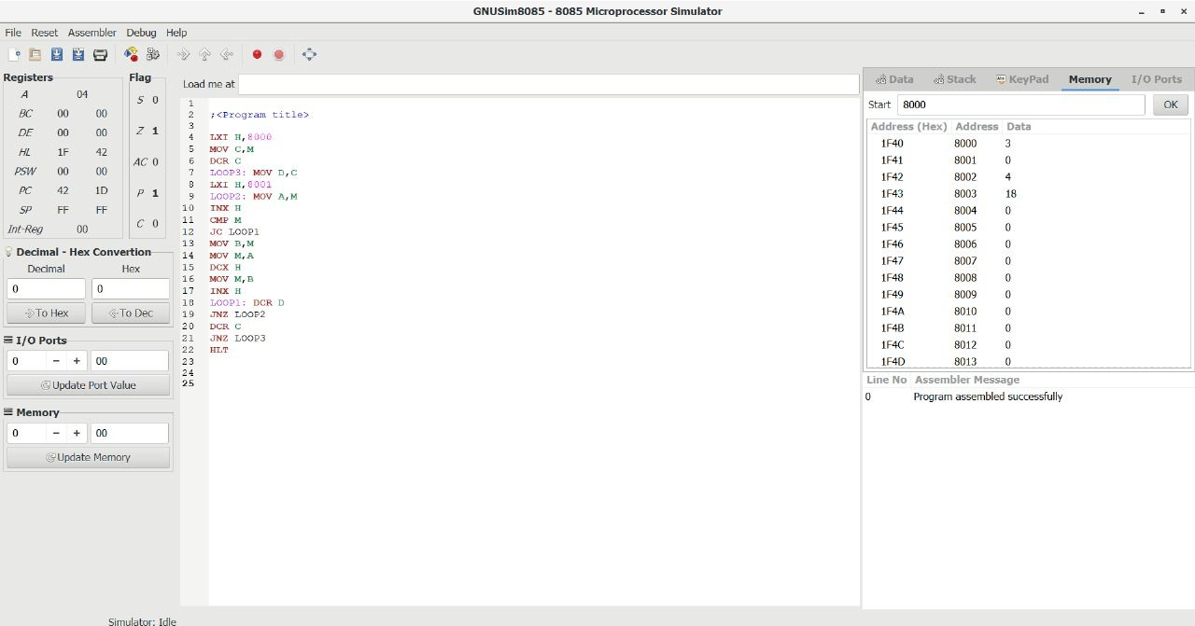

**RESULT:** Thus the program was executed successfully using 8085 processor simulator.